* **Project Title:  
  Beyond Statistics: Unveiling the Best Playing 11 for the 2022 T20 World Cup through Data Analysis**

**V Saikrishna – 20BCI7222 – VIT-AP**

**1. Overview of the Problem**

The T20 format of cricket is a fast-paced and dynamic game that places a premium on explosive batting, versatile all-rounders, and effective bowling attacks. Selecting the best playing 11 for a T20 World Cup tournament requires a careful consideration of player strengths, role-specific requirements, and team balance. This project aimed to identify the best playing 11 for the 2022 T20 World Cup through a comprehensive data analysis approach.

**2. Data and Modeling Approach**

The project utilized a data-driven approach to identify the best playing 11 for the 2022 T20 World Cup. The process involved the following steps:

Data Collection:

* Data on player performance from the 2022 T20 World Cup was collected from the ESPNcricinfo website using web scraping techniques.

Data Cleaning and Preprocessing:

* The collected data was cleaned and preprocessed to ensure consistency, accuracy, and completeness. This involved handling missing values, identifying outliers, and correcting any inconsistencies in data formats.

Data Analysis and Player Evaluation:

* Statistical measures were calculated for each player, including batting average, strike rate, innings batted, balls faced, batting position, bowling economy, bowling strike rate, bowling style, bowling average, and dot ball percentage.
* Players were categorized based on their batting position and bowling style, such as openers, anchors, finishers, all-rounders, specialist spinners, and specialist fast bowlers.
* Players were evaluated against the defined criteria for each player role. These criteria were established based on the specific requirements and expectations of each role in the T20 format.

Model Selection:

* A multi-criteria decision-making (MCDM) approach was employed to select the best players for each role based on their statistical performance and adherence to the defined criteria. MCDM techniques allow for the consideration of multiple factors and objectives simultaneously.

**3. Results of Data Analysis**

The data analysis and player evaluation process resulted in the selection of the following best playing 11 for the 2022 T20 World Cup:

|  |  |  |
| --- | --- | --- |
| Position | Player Name | Role |
| 1 | Jos Buttler | Opener |
| 2 | Rilee Rossouw | Opener |
| 3 | Alex Hales | Opener |
| 4 | Virat Kohli | Anchor |
| 5 | Suryakumar Yadav | Anchor |
| 6 | Glenn Phillips | Finisher |
| 7 | Marcus Stoinis | All-rounder |
| 8 | Sikandar Raza | All-rounder |
| 9 | Shadab Khan | Specialist spinner |
| 10 | Sam Curran | Specialist fast bowler |
| 11 | Shaheen Shah Afridi | Specialist fast bowler |

drive_spreadsheetExport to Sheets

**Dashboard:**

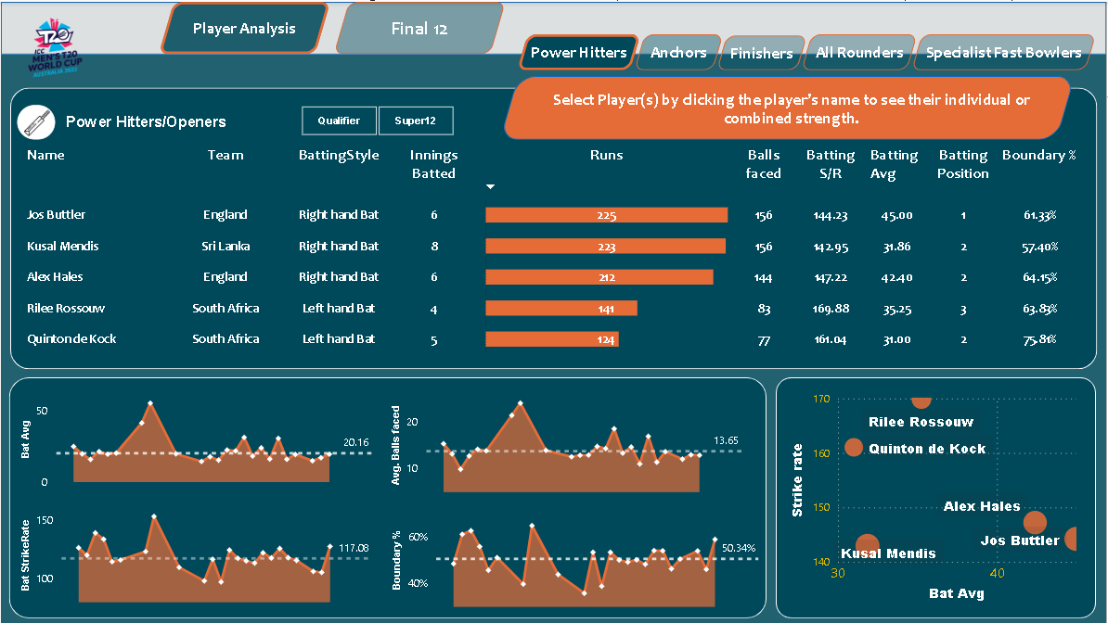

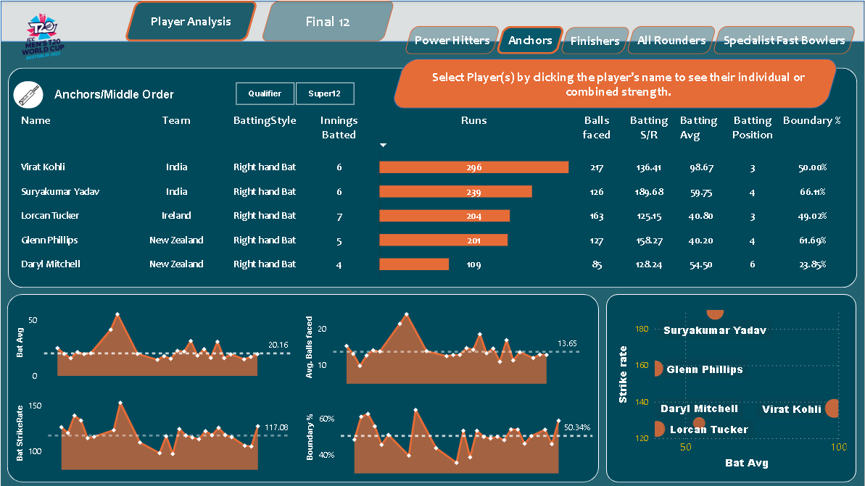

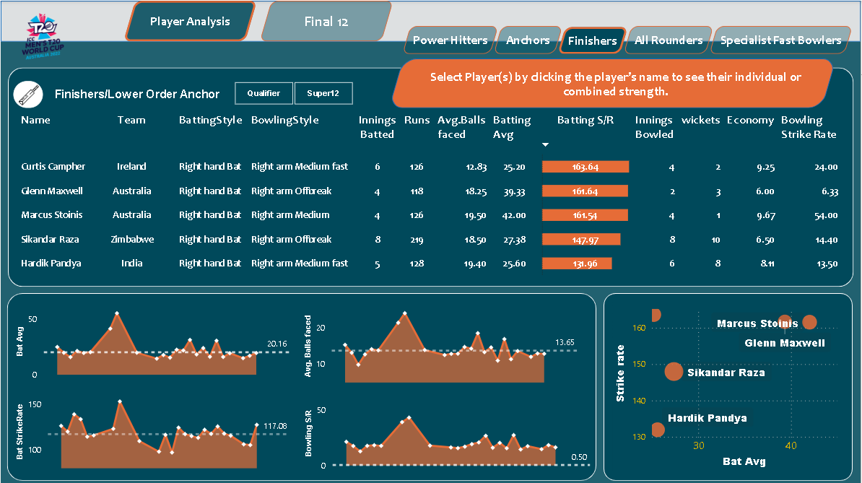

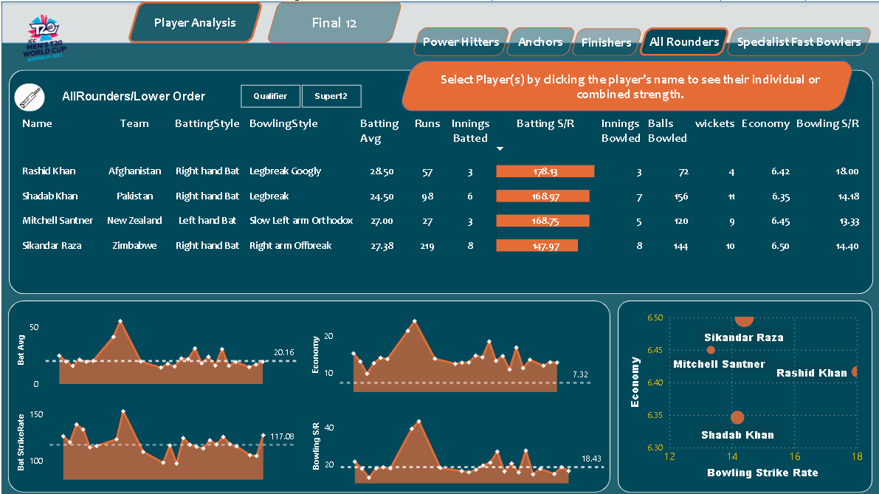

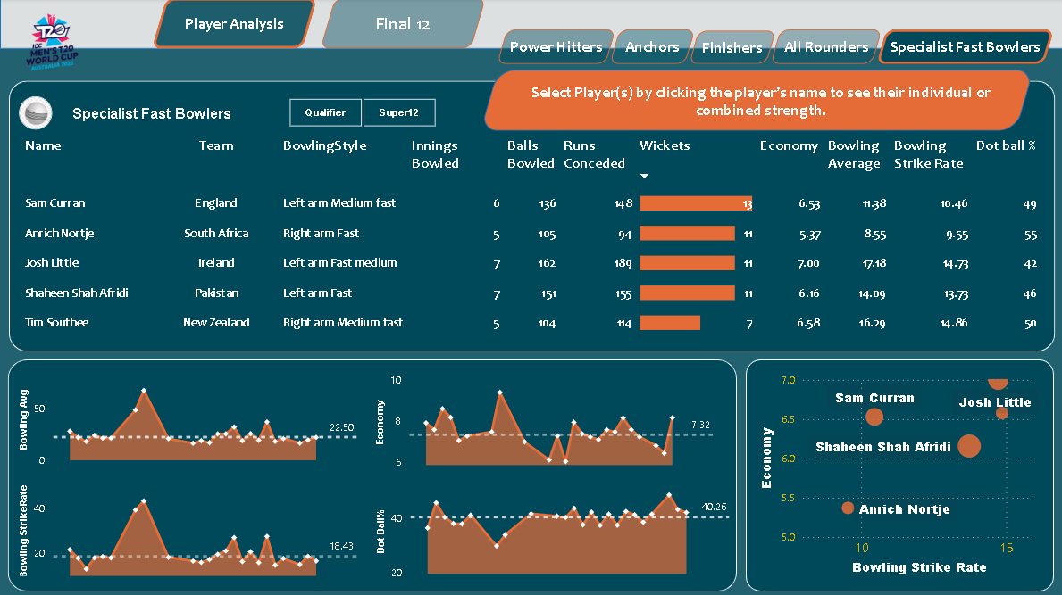

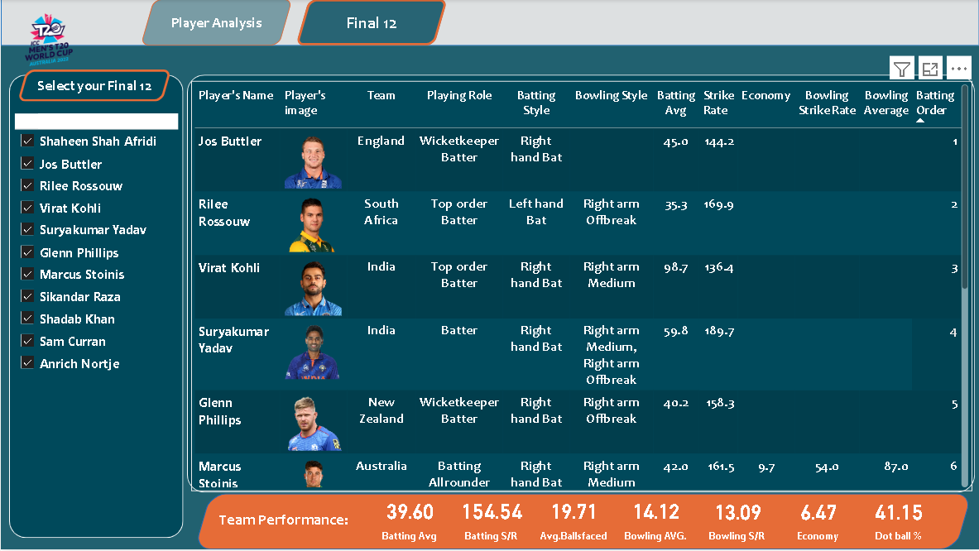

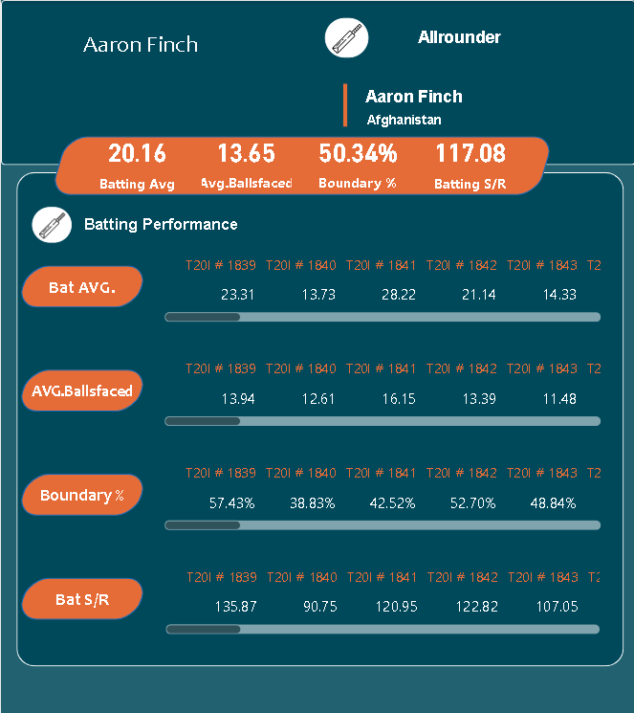

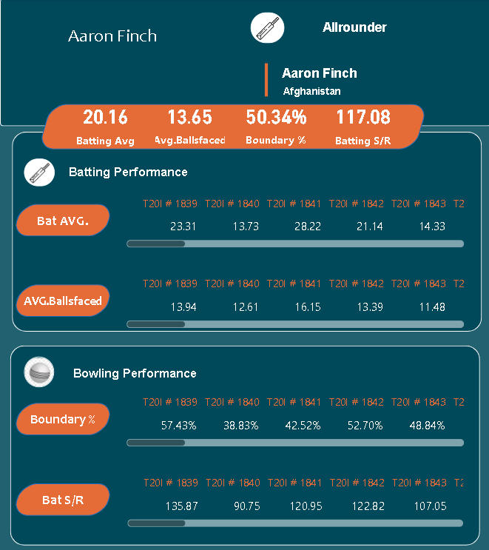

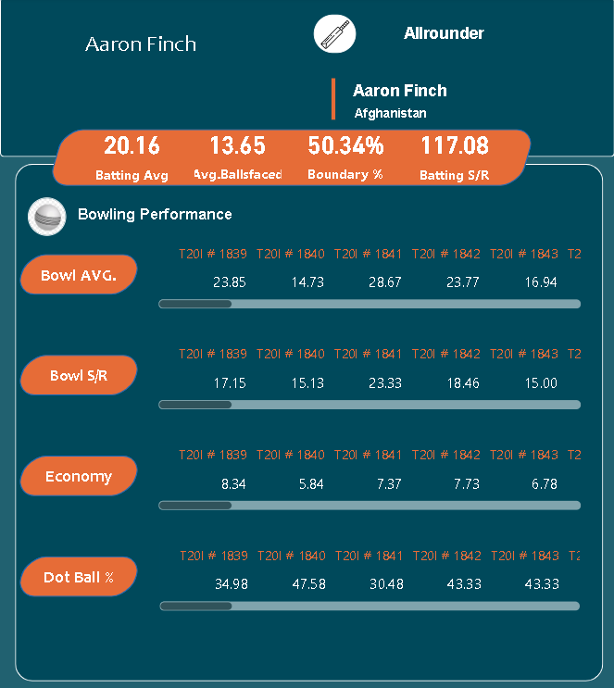

**4. Substantive Conclusions**

The data analysis revealed that the best playing 11 for the 2022 T20 World Cup comprised a balanced combination of players with the following strengths:

* Experienced and explosive openers: Jos Buttler, Rilee Rossouw, and Alex Hales provide a solid foundation for the team's batting, capable of setting high targets early in the innings.
* Consistent and dependable anchors: Virat Kohli and Suryakumar Yadav bring stability and experience to the middle order, ensuring a steady flow of runs throughout the innings.
* Versatile all-rounders: Marcus Stoinis and Sikandar Raza offer a combination of batting and bowling skills, providing flexibility and balance to the team's composition.
* A reliable specialist spinner: Shadab Khan's ability to control the run rate, take wickets, and bowl economically makes him a valuable asset in the T20 format.
* Two high-impact specialist fast bowlers: Sam Curran and Shaheen Shah Afridi bring pace, wicket-taking ability, and variety to the bowling attack, making them crucial components of the team's success.

This team composition aligns with the demands of the T20 format, emphasizing the importance of explosive starts, middle-order stability, all-round contributions, spin control, and pace bowling prowess. The selection of this best playing 11 was based on a comprehensive data analysis approach that considered various statistical measures, player roles, and team balance.  
  
  
**Github Link:**[**https://github.com/vuppulasaikrishna/Beyond-Statistics-UnveilingT20-World-Cup-through-Data-Analysis**](https://github.com/vuppulasaikrishna/Beyond-Statistics-UnveilingT20-World-Cup-through-Data-Analysis)